AP Capstone is made up of two courses: AP Seminar and AP Research. AP Seminar is taken in 10th or 11th grade, and AP Research is taken in 11th or 12th grade. You must take Seminar in order to take Research.

ALL INCOMING 9TH GRADE STUDENTS, see page 3 for how you can begin your Capstone journey!

**So why should you take them?**

* Learn foundational critical thinking, reading, and writing skills needed for college and beyond
* Set yourself apart from the thousands of other students applying for college and university
* Check off on the Common Application Form that you are an AP Capstone Candidate
* Receive the AP Capstone Certificate: if you earn a qualifying score on the Seminar and Research AP exams
* Receive the AP Capstone Diploma: if you earn a qualifying score on the Seminar and Research AP exams and earn qualifying scores on 4 other AP exams

**Seminar: An Overview**

* Prerequisite for AP Research
* Develop analytic and inquiry skills
* Explore issues in a variety of fields according to your interest
* Sets the foundation for skills you will use in AP Research
* Team project
* Individual paper and presentation
* AP exam

**Research: An Overview**

* Second course in the AP Capstone program
* Focuses on the skills learned in Seminar, applied to individual research, research methodology, ethical research practices, analysis of information, defense of research
* Design, plan, and conduct research study based on a topic you are interested in
* Academic paper (4,000-5,000 words)
* Presentation and Oral Defense
  + Paper and Presentation and Oral Defense count as the AP exam

**Is it worth it?**

***Yes***. Every student who has taken AP Capstone has shared how it helps them in college—with reading and writing, with time management, with speaking in front of others, and with critical thinking. Several students have impressed professors by being the only students in the class who have conducted formal research studies. Students have been admitted to Ivy League schools, earned entrance into Honors Colleges, received scholarships, earned coveted spots in research labs, and earned college credits as a direct result of AP Capstone.

**Wait! I heard colleges don’t care about Capstone.**

This is false. According to the College Board, “To date, over 100 public and private institutions have indicated that they have or are working on policies to welcome students who successfully complete AP Capstone.” Students earn:

* College credit in English, Research, independent study, or elective courses,
* Entrance into the Honors College,
* Scholarships

Often, you can petition the college to receive content-based credit for the Capstone courses, especially in the field related to your research. You will leave AP Research with a full portfolio of your year-long research.  
The Common Application Form (which you will use to apply to colleges) has a distinction for AP Capstone Candidates! This illustrates how important this program is to colleges and universities around the world.

Here are the institutions in Florida that recognize and reward AP Capstone Candidates:

* Chipola College
* College of Central Florida
* DeVry University: Miramar
* DeVry University: Orlando
* Eastern Florida State College
* Eckerd College
* Embry-Riddle Aeronautical University: Worldwide Campus
* Flagler College
* Florida Agricultural and Mechanical University
* Florida Atlantic University
* Florida College
* Florida Gulf Coast University
* Florida Institute of Technology
* Florida International University
* Florida Keys Community College
* Florida Polytechnic University
* Florida SouthWestern State College
* Florida State University
* Gulf Coast State College
* Hillsborough Community College
* Indian River State College
* Johnson and Wales University North Miami Campus
* Lynn University
* Miami Dade College
* North Florida Community College
* Northwest Florida State College
* Nova Southeastern University
* Pasco-Hernando State College
* Pensacola State College
* Polk State College
* Rollins College
* Saint Johns River State College
* Saint Leo University
* Saint Thomas University
* Santa Fe College
* Seminole State College of Florida
* Southeastern University
* St. Petersburg College
* Stetson University
* University of Central Florida
* University of Florida
* University of Miami
* University of North Florida
* University of South Florida
* Valencia College

What about other institutions out of state? Check out the full list of all institutions here: <https://apcentral.collegeboard.org/courses/ap-capstone/higher-education-endorsement>

***Out-of-state colleges that support AP Capstone include Purdue University, The Ohio State University, Massachusetts Institute of Technology, Clemson, Harvard, Yale, and Georgetown.***

**AP Seminar was hard! I don’t want to take a hard class my senior year.**

First, all AP classes are hard to some extent. They are college-level courses, so they are, by nature, more difficult than high school classes. Second, colleges and universities EXPECT you to challenge yourself with rigorous courses throughout your high school career, INCLUDING senior year! If you stop taking higher-level courses, this could hurt your chances of gaining entrance into more prestigious institutions. Third, the skills you learn in Seminar and Research will be beneficial regardless of what you choose to do later in life. Knowing how to read, write, think critically, defend your argument, and speak in front of others are skills that can be used in any career and are foundational to success.

**What if I don’t get a qualifying score on the AP Seminar exam?**

You can still take AP Research. While you won’t be eligible for the AP Capstone Certificate or Diploma, you WILL still learn and grow, gaining those foundational skills; and, if you earn a qualifying score on the AP Research exam, you can still get college credit for that course.

Come chat about AP Seminar with Mr. Poth or AP Research with Mrs. Guardabascio! We’re excited to have you become an AP Capstone Scholar!

Check out the College Board’s site for more information: https:// collegeboard.org/apcapstone

**What if I’m a freshman? May I take AP Seminar?**

We are excited to offer a new “Pre-AP” Argument Analysis Honors course combination specifically for incoming freshmen! Argument Analysis Honors will help students deepen their critical reading analysis through challenging informational text, including academic research studies, and build upon their knowledge of argument writing. The course is a combination of Semantics and Logic Honors and Reading Honors. **These two Honors courses** are on a 4.5 grading scale and **are**, therefore, **advanced courses**. The Florida Standards for each of these two courses include reading and writing skills up through grade 12. This “Pre-AP” combination will help 9th grade students understand the nature of academic argument, learn how to synthesize difficult texts from varying perspectives, and avoid the common pitfalls in argument writing. As a result, freshmen who complete these courses will have a solid foundation for AP Seminar as a sophomore.

**What if I’m not sure about AP Capstone? Should I still take Argument Analysis Honors?**

The short answer is yes! This foundational class will assist all students in building skills to help them succeed in all of their AP course endeavors. Critical reading and thinking plus effective writing is applicable for academic purposes and beyond. These are skills that students will bring to their careers.

Ask your guidance counselor today about adding this course combo to your selection choices for next year. If you have questions about the course, please contact Mrs. Guardabascio (guardabascioa@pcsb.org).

[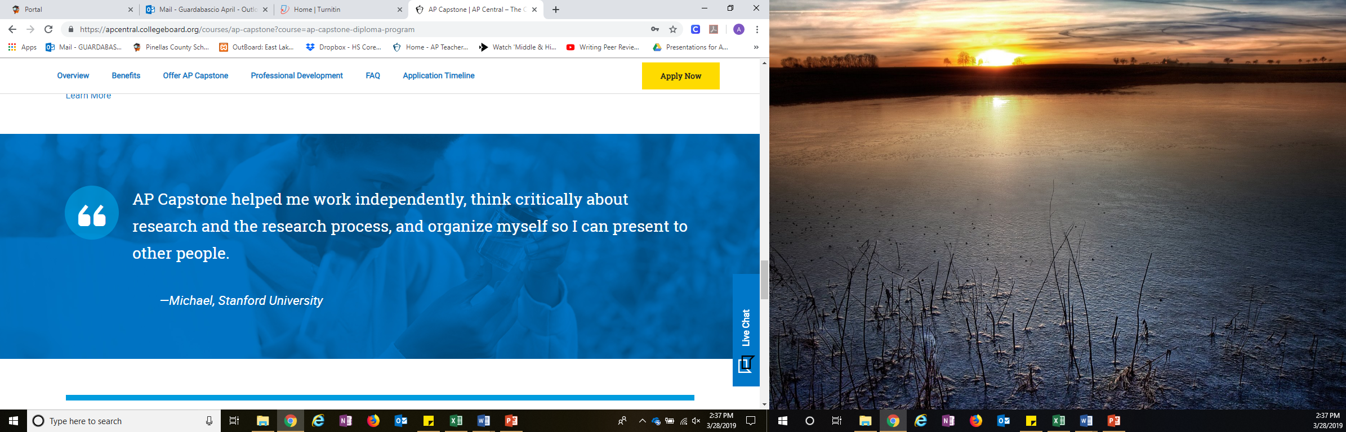](https://apcentral.collegeboard.org/courses/ap-capstone?course=ap-capstone-diploma-program)Collegeboard.org/apcapstone

**Why was the AP Capstone Diploma program created?\***

The AP Capstone Diploma program launched in fall 2014. We developed the program after hearing from higher education faculty and administrators who were seeking incoming freshmen with proficiency in critical thinking and communication skills. Specifically, these higher education professionals wanted to identify students who were able to analyze different perspectives, evaluate the credibility of sources, use scholarly methods, build evidence-based arguments, work in teams, work with mentors, and develop and deliver team and individual presentations.   
Successfully completing an AP Capstone course or earning one of the AP Capstone awards communicates to colleges and universities that an applicant has these skills.   
*taken from FAQ on collegeboard.org/apcapstone